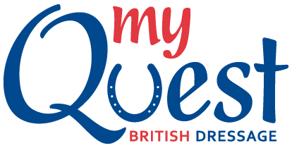
Why not have a go at My Quest in 2019 at Caron Roberts Equestrian.
All the normal format for BD but a little more relaxed and on a fraction of the membership costs as you only have to be Club members which is £30 a rider and £10 per horse.
If you are already a current BD member then you are still able to compete in My Quest as long as you are eligible for the BD Bronze section.
There are 2 sections, Open & U21’s (for riders up to the end of the year of their 21st birthday) and the competition levels are Intro, Prelim & Novice.
The qualifying period for Quest is from the 1st December – 31st August
When you register you will be allocated into a Region and there will be
Regional rankings taking your top 5 scores into account - one for Open and one for Under 21 at each level from Intro to Novice.
60.00 - 61.99% 1 point
62.00 - 63.99% 2 points
64.00 - 65.99% 3 point
66.00 - 67.99% 4 points
68.00 - 69.99% 5 point
70.00 - 71.99% 6 points
72.00 - 73.99% 7 point
74.00 - 75.99% 8 points
76.00 - 77.99% 9 point
78.00 - 79.99% 10 points
80.00% and above 11 point

My Quest riders will collect points from their % scores and the top 20 in our region will qualify for the Regionals which take place in Sept/Oct with the top 4 going through to the Nationals taking place at Bury Farm in late October 2019.
The full BD Rules & Eligibility can be found on the BD website https://www.britishdressage.co.uk/competitions/team_quest

