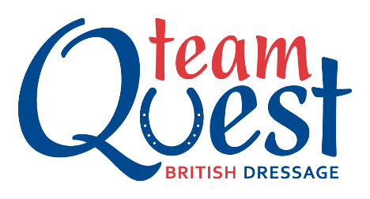
From February 2019 we will be hosting BD Quest competitions at Caron Roberts Equestrian.
Team Quest gives you the opportunity to compete at Intro, Prelim & Novice level with a team of friends with your own team name and colours.
There are 2 sections, Open & Under 21’s (for riders up to the end of the year of their 21st birthday) for all competition levels.
Some of the BD rules have been relaxed for Team Quest such as Jackets not compulsory, commanders and whips allowed at all levels including regionals and nationals.
Teams will be made up of 3 or 4 riders on the day but you can register up to 7 riders with BD and you only have to be BD Club members which Just £30 a rider and £10 a horse.
Team Quest is also open to current full BD members who are eligible to ride in Bronze.
Team Quest opens on the 1st December till 31st August. Team placings will be converted into points.
1st = 10 pts
2nd = 9 pts
3rd = 8 pts
4th = 7 pts
5th = 6 pts
6th = 5 pts
7th = 4 pts
8th = 3pts
9th = 2 pts
10th = 1 pt

When you register your team with BD you will be allocated into a Region and team scores will be recorded into result tables and the best 5 team scores will count.
The top 15 teams in our region will qualify for the Regionals which take place in Sept/Oct with the Nationals taking place in late October.
The full BD Rules & Eligibility can be found on the BD website https://www.britishdressage.co.uk/competitions/team_quest

